SPAM EMAIL DETECTION SYSTEM

Project Id: 22

Name : LICHHAVI CHAUHAN (Team Leader)
Class Roll Number:50
University Roll Number : 2028755
Section and Group: P and G2

Name : LIPIKA LATWAL
Class Roll Number: 51
University Roll Number : 2028756
Section and Group: P and G2

- Problem Description 3
- Architecture 4
- Models model 5
- Evaluation metrics used 6
- Preliminary Results and Visualizations 7-10
- References 11

- Problem Description
Email spam is a major problem in digital communication, flooding inboxes with unwanted, misleading, or malicious messages. Manually filtering these emails is time-consuming and unreliable. This project aims to build an automated spam detection system using machine learning techniques. The system takes raw email text as input and processes it through a pipeline: text is cleaned by removing stop words and punctuation, then converted into numeric features using Bag of Words (Count Vectorizer) Four classification models are trained and compared — Logistic Regression and Support Vector Machine (SVM) with three kernel types: Linear, Polynomial, and RBF. Each model learns patterns from labelled email data to distinguish spam from ham (NON SPAM EMAIL) messages. Model performance is evaluated using accuracy scores and confusion matrices, providing a clear picture of each model's strengths and weaknesses .The goal is to identify the most effective algorithm for spam classification, contributing to safer and cleaner email communication.

- Architecture
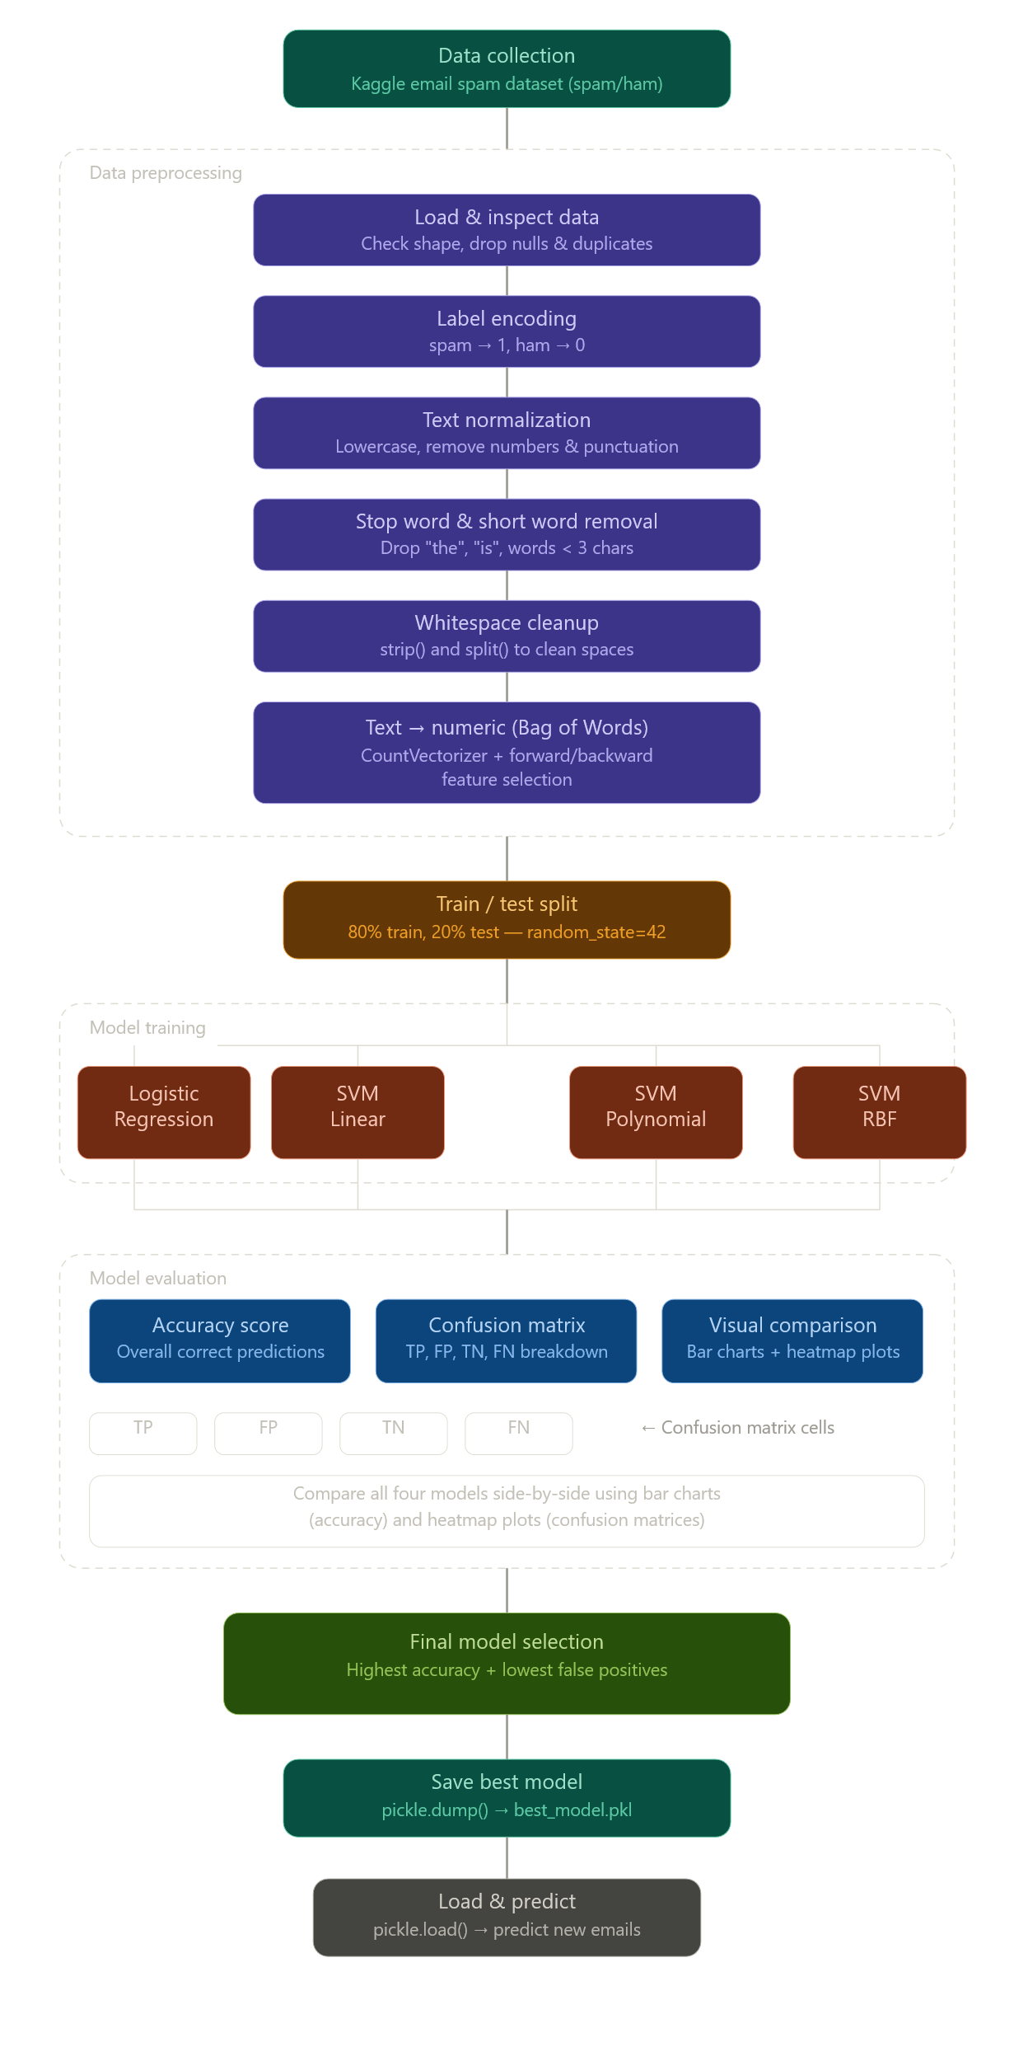

- Models Used(Applied/ Planned) Give a brief introduction of the models used
- LOGISTIC REGRESSION
Despite its name, Logistic Regression is a classification algorithm, not a regression one. It learns the probability that an email belongs to the spam class by fitting a sigmoid (S-shaped) curve to the word-count features. It draws a single straight decision boundary between spam and ham in the feature space — simple, fast, and highly interpretable.
Kernel / boundary Linear (sigmoidfunction)
Training speed Very fast
Interpretability High — feature weights
are readable
Best for Linearly separable text
data
2.SVM — Linear kernel
A Support Vector Machine finds the hyperplane that best separates spam from ham with the maximum margin — meaning it pushes the decision boundary as far as possible from both classes. The linear kernel works directly in the original word-count feature space, making it extremely effective for high-dimensional text data like bag-of-words vectors.
Kernel Linear
Decision boundary Straight hyperplane
Works well when Data is linearly separable
Training speed Moderate

3.SVM — Polynomial kernel
The polynomial kernel allows SVM to learn curved, non-linear decision boundaries
by implicitly mapping the input features into a higher-dimensional polynomial space.
With degree=3 (cubic), it can capture interactions between words — for example, the
combination of "click", "free", and "now" being stronger spam signals together than
individually.
Kernel Polynomial (degree = 3)
Decision boundary Curved (cubic)
Captures Word combination patterns
Training speed Slower than linear

4.SVM — RBF kernel
The Radial Basis Function (RBF) kernel is the most powerful and flexible SVM variant.
It measures similarity between data points using a Gaussian bell-curve function,
allowing it to capture complex, non-linear patterns. It can wrap decision boundaries
around clusters of spam words in any shape — making it suitable even when spam and
ham patterns are not easily separated by lines or curves.
Kernel RBF (Gaussian)
Decision boundary Highly flexible / non-linear
Captures Complex feature clusters
Training speed Slowest of the four

- Evaluation metrics used

1. Accuracy Score: Measures the percentage of emails correctly classified out of total test emails. Used to compare all four models and identify the best performer.
2. Confusion Matrix: A 2x2 table showing TP, TN, FP, FN values for each model. Used because accuracy alone does not reveal where the model is making mistakes.
3. True Positive (TP) :Number of spam emails correctly identified as spam. Higher TP means model is catching real spam successfully.
4. True Negative (TN): Number of ham emails correctly identified as ham. Higher TN means legitimate emails are passing through safely.
5. False Positive (FP) :Number of legitimate emails wrongly blocked as spam. Most critical error — model with lowest FP is preferred for real world use.
6. False Negative (FN) :Number of spam emails that slipped through as ham. Less harmful than FP but still undesirable.

5. Preliminary Results and Visualizations
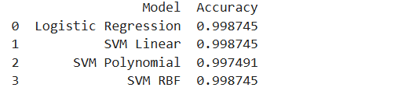
Fig1. All four models accuracy

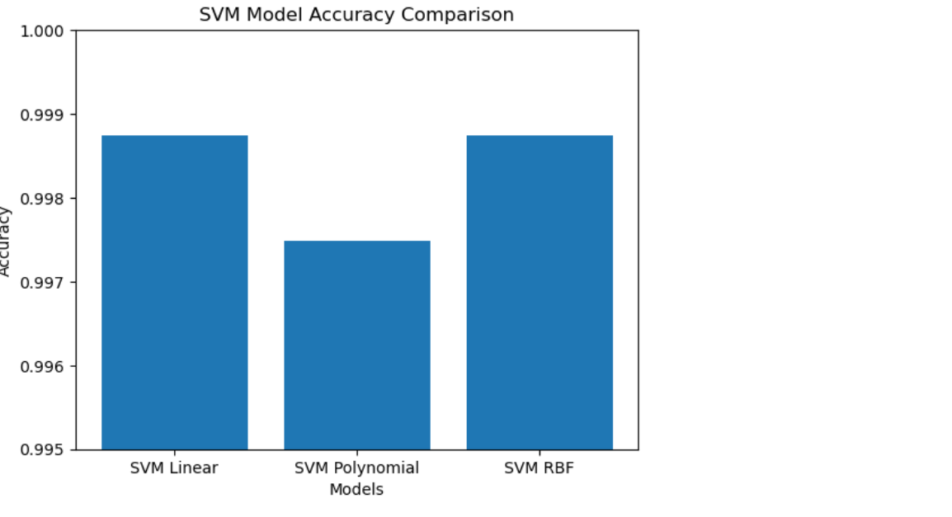

Fig2.SVM model accuracy comparsion
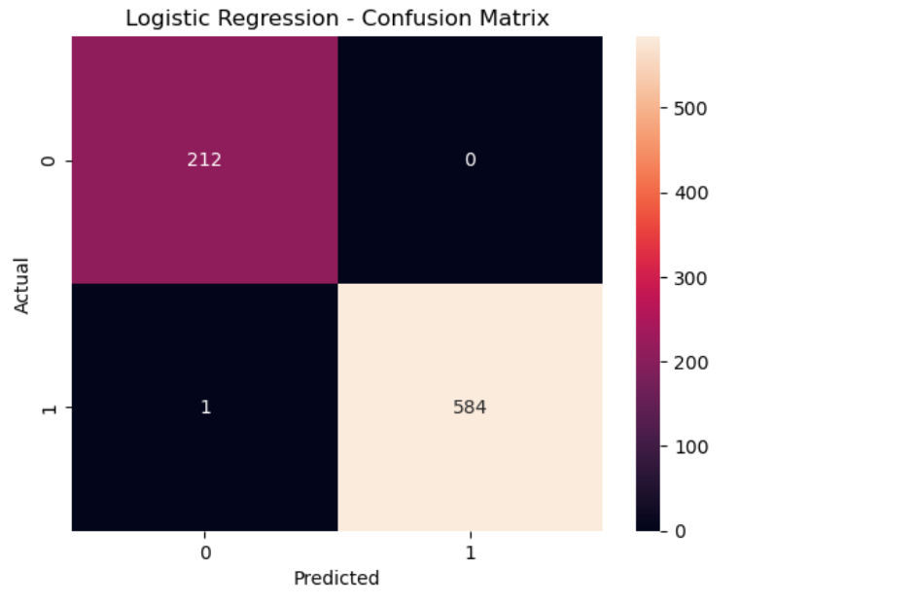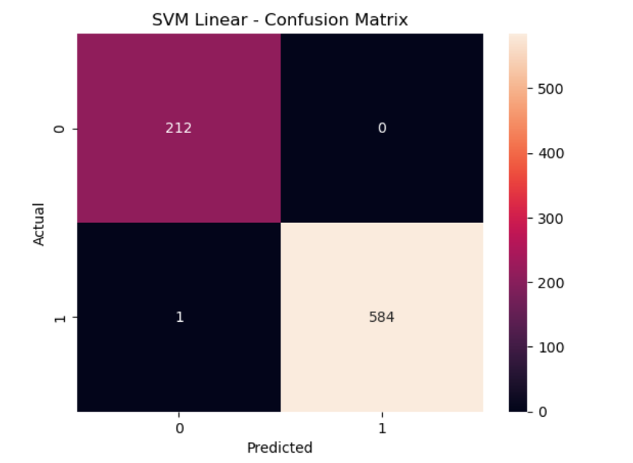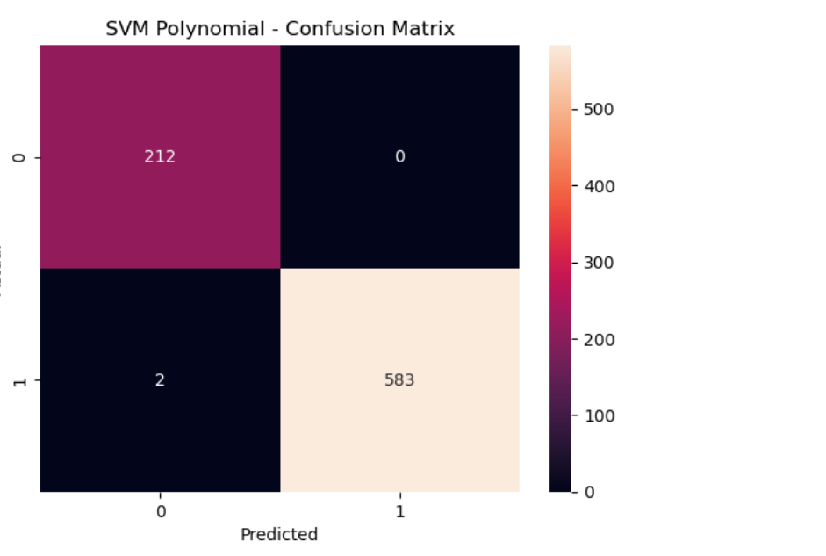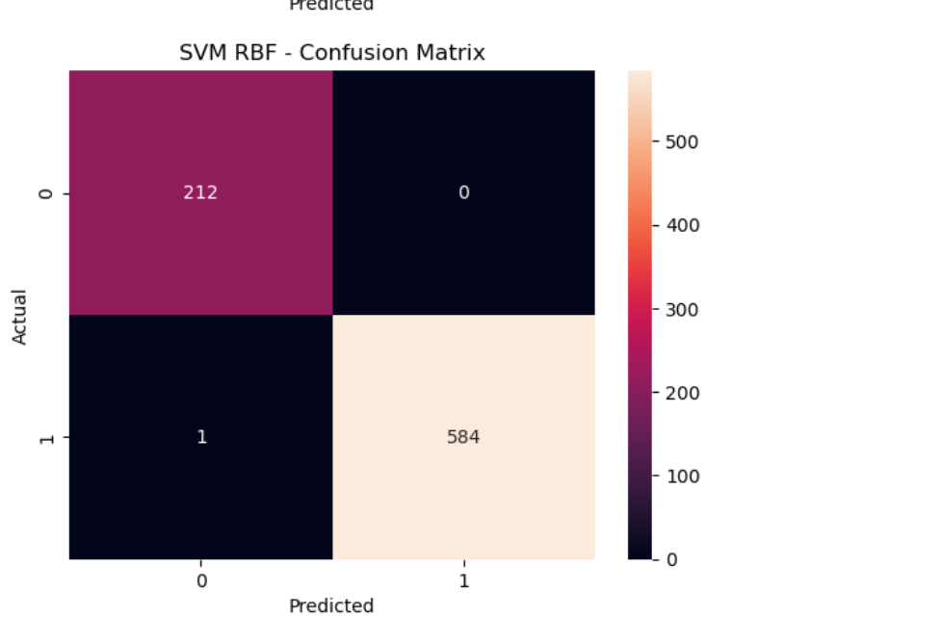

Fig 3. Heatmap of all four models

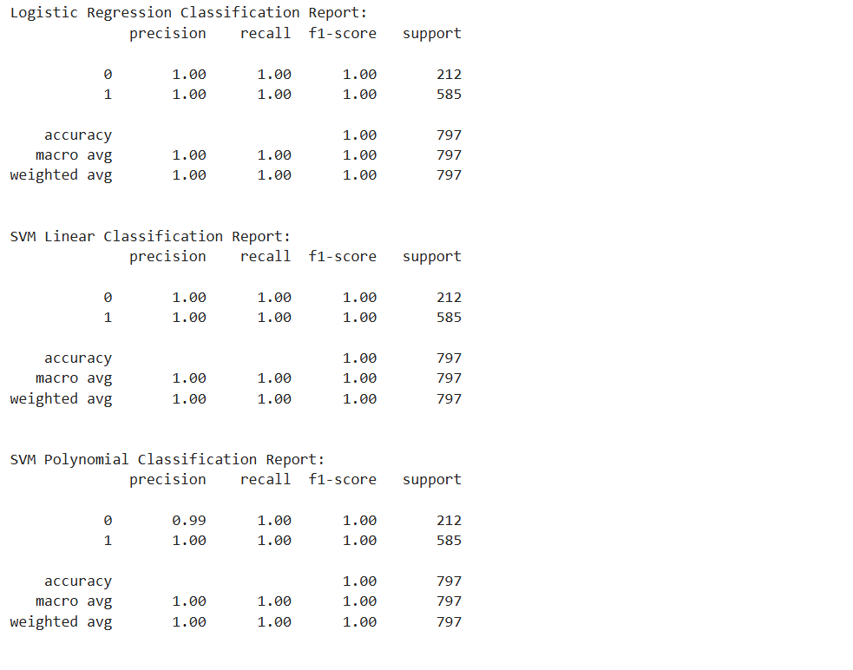

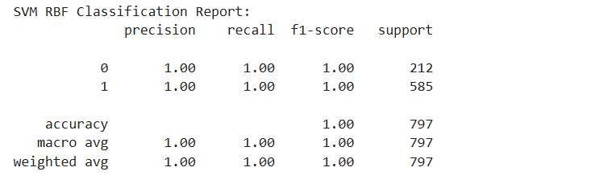

Fig4 : classification report all models

6. References:
Books:
- Artificial intelligence and machine learning – S. CHAND

Online Resources:
https://scikit-learn.org/stable/modules/generated/sklearn.feature_extraction.text.CountVectorizer.html
https://www.geeksforgeeks.org/bag-of-words-bow-model-in-nlp/

